JUNE 4, 2017

My long road to recovery...

http://blog.helpgrowusa.com/my-long-road-to-recovery
By Christopher Erle Member Post
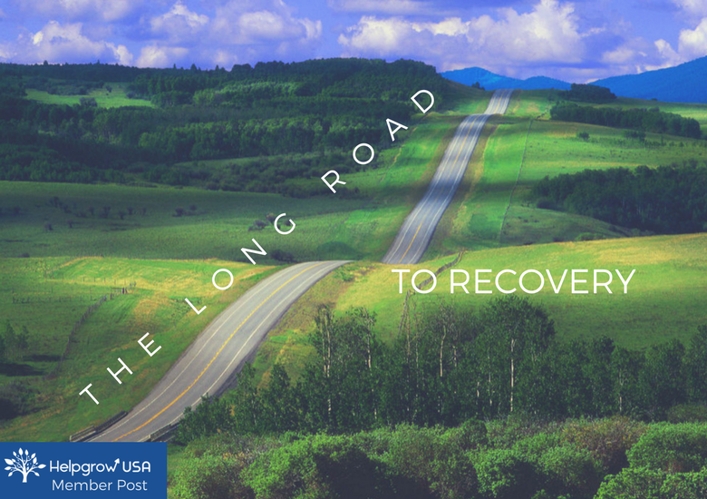
Two-and-a-half years ago, I had a very traumatic brain injury. Before this, I was a contortionist, sword swallower, music maker, writer, and a photographer. I did all of these things for work, sometimes all at the same time.
I could only use my fingers after my injury. I had no motion in my legs or arms. I had to re-learn how to use my body. I could only say the word "love." This is called aphasia. I had to relearn the entire English language. Now, I am a writer again, but I can't tell you just how hard it was to get my abilities back. Each word was work, and I'm still learning new words all the time.

For the first year, I couldn’t write or say anything. It wasn’t until after a year in recovery that I was finally able to write a little. The first thing that I wrote was 24 new pages in my book. I was so desperate to get back to it. I was even more desperate to get back to my old life.

Now, I work every day to get my life back. I work to be a contortionist again, sword swallowing, making music and trying to re-learn how to use my voice. I wrote 29 songs before my brain injury. Our band was called All Systems A GoGo.

I used to work with some of the biggest companies in the United States, like Georgia Pacific (Dixie, Quilted Northern, Brawny, and Angel Soft), Papa John’s, Sandvik Mining, Nestle, Juice Plus+, Laser Spine Institute, mBlox, GAP International, and Arby’s. I worked with these companies in creating advertisements as a writer/photographer.

Now that I can write and do photography again, I’m ready to work. I’ve written five articles so far since my recovery. 4 of them are in QVegas and the other, the newest article, is for the Borgen Project. Borgen Project helps countries with very awful poverty. It feels incredible to be a journalist again and writing about things that people really need to know about.

I more than anything, miss working. I loved working with companies with their advertisements because it was very creative, and I’m all about creative duties. I now have a list of things that I do every day. I take photographs daily, and I have taken a classes to learn even more about photography. I'm getting the ability to create back, along with everything else. It's going to take at least one more year to get my whole life back, but I'm going to do it. I have to because I miss all of those skills and talents. They make me who I am. I have done so much for a man who is only 29, and I can't wait to see what I'm going to do in the future.

- Christopher Erle/Chris Twist (Chris Twist is my name as a performer)

